Week 5 – Jacob and Esau

Using the card people cut outs make one Esau who was hairy, use wool and fabric to make him feel hairy and the other Jacob who was smooth. You can stick a lolly stick on the back of each of them to make puppets.
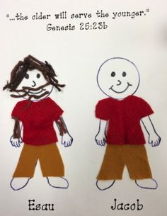
Additional ideas for you to try at home

Read the story in Genesis 25 verse 19-34

Make your own beard to be hairy like Esau you can do this with card and paper, cotton wool or wool, have fun and act out the story with your family or friends!

