Week 3 – Noah

Make a mosaic picture of the rainbow to remember the promise God made to Noah, stick small squares of colour onto each arch of the rainbow.

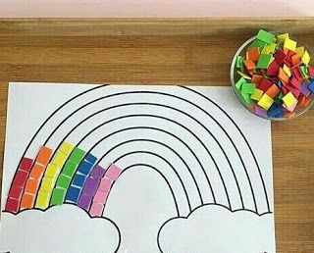

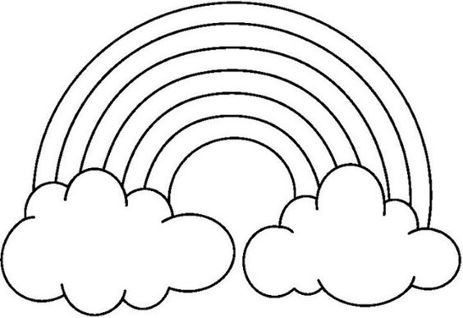
Additional ideas for you to try at home
Read the story in Genesis 6 verses 9 to Genesis 8 verse 20
Make a Moving Ark picture, follow the link https://www.pinterest.co.uk/pin/393853929923137619/ Make a 3D rainbow
For templates and instructions
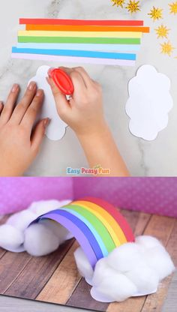
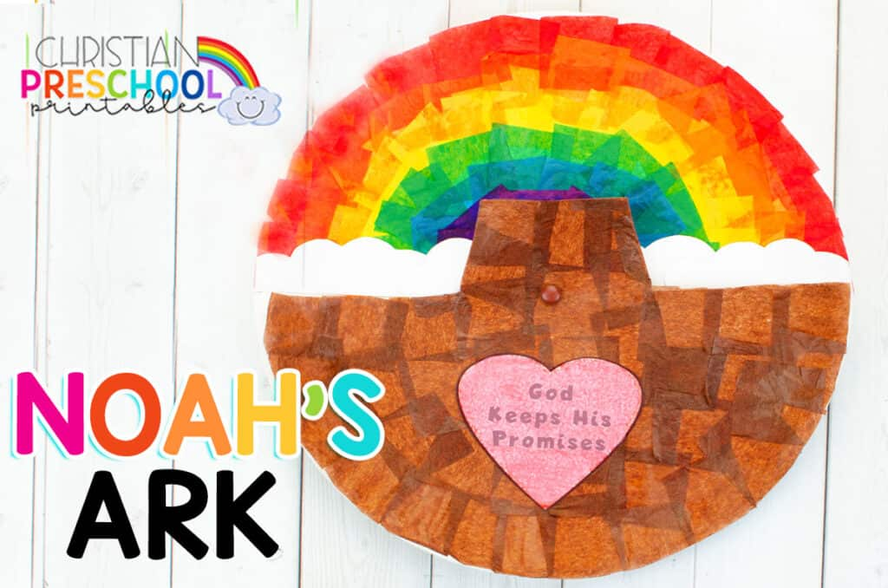

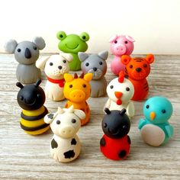

Make animals to go into the Ark with the playdough you made on week one

Make some animal biscuits and create your own Ark dessert

