Yeovil Community Church - Summer 2021 - Creative Ideas
Week 1 – Creation

Make a picture ordering the days in which God created the world Using the play dough create an animal or plant. Here is a recipe
Best Ever No-Cook Play Dough Recipe! - The Imagination Tree

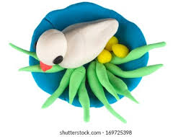
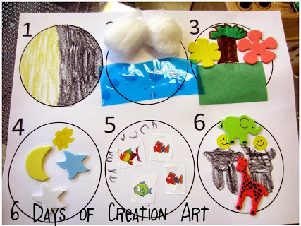

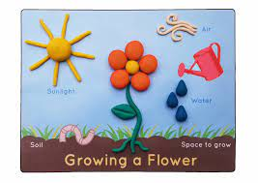
God Created the World
Day 1 Day 2 Day 3

Extra Ideas for you to try at home

Re tell the creation story by using Lego to make the world Make a paper chain with a different day of creation on each piece
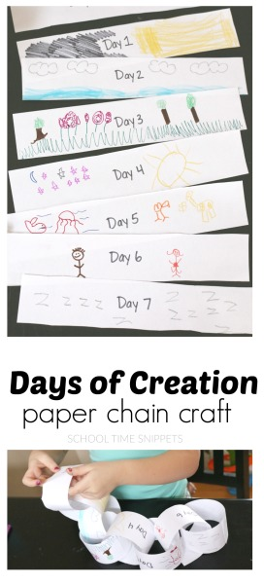
and everything in it such as plants, birds animals and people.
You could make a little film on a mobile phone.
