Week 2 – Adam and Eve

Make a tree with a circle of green card for the leaves and branches. You can decorate it with some fruits and leaves by scrunching up tissue paper and gluing it on.
Take your card tube trunk and carefully make two cuts, one at each side to slot the top of your tree into.
Next take your pipe cleaner and make a head for your snake, gluing on the googly eyes and wrap it around your tree trunk. A bit of sticky tape will keep it in position.

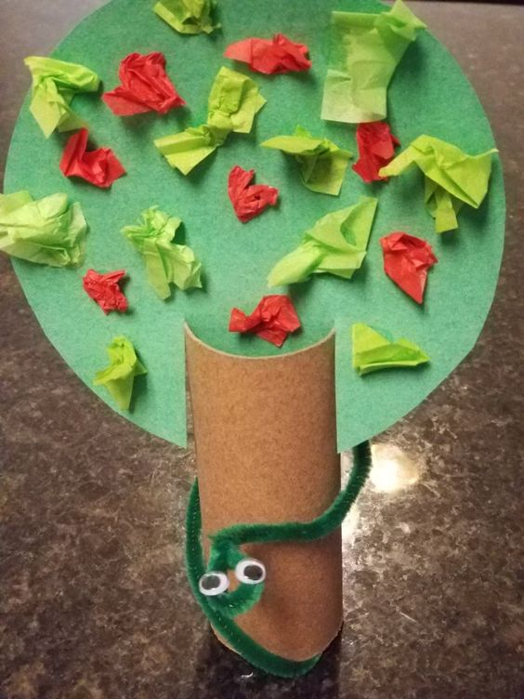

Additional Ideas for you to try at home
Read more of the story in Genesis chapter 2.
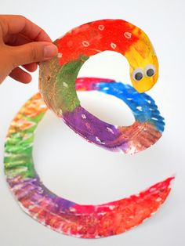
Make a spiral snake, using a paper plate or circle of paper cut round,
until you get to the middle. Decorate it as you like.

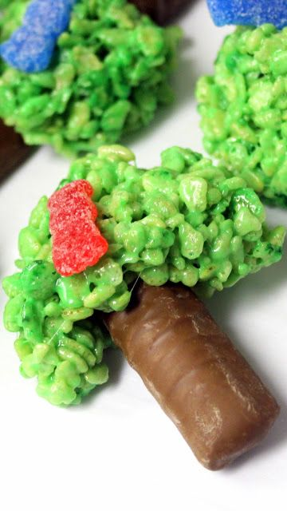
Make an edible tree of life. Melt white chocolate and mix in green food colouring to make the leaves of the tree. Decorate with jelly sweets for the fruit and use a chocolate finger for the trunk. You could even add a jelly snake if you have one!

