Week 4 – Abraham & Isaac
Abraham had no children with his wife Sarah God gave him the promise of more descendants than the number of stars in the sky.

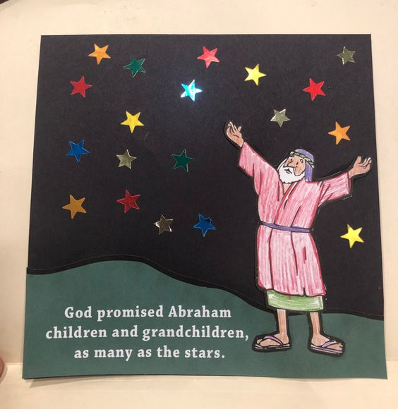
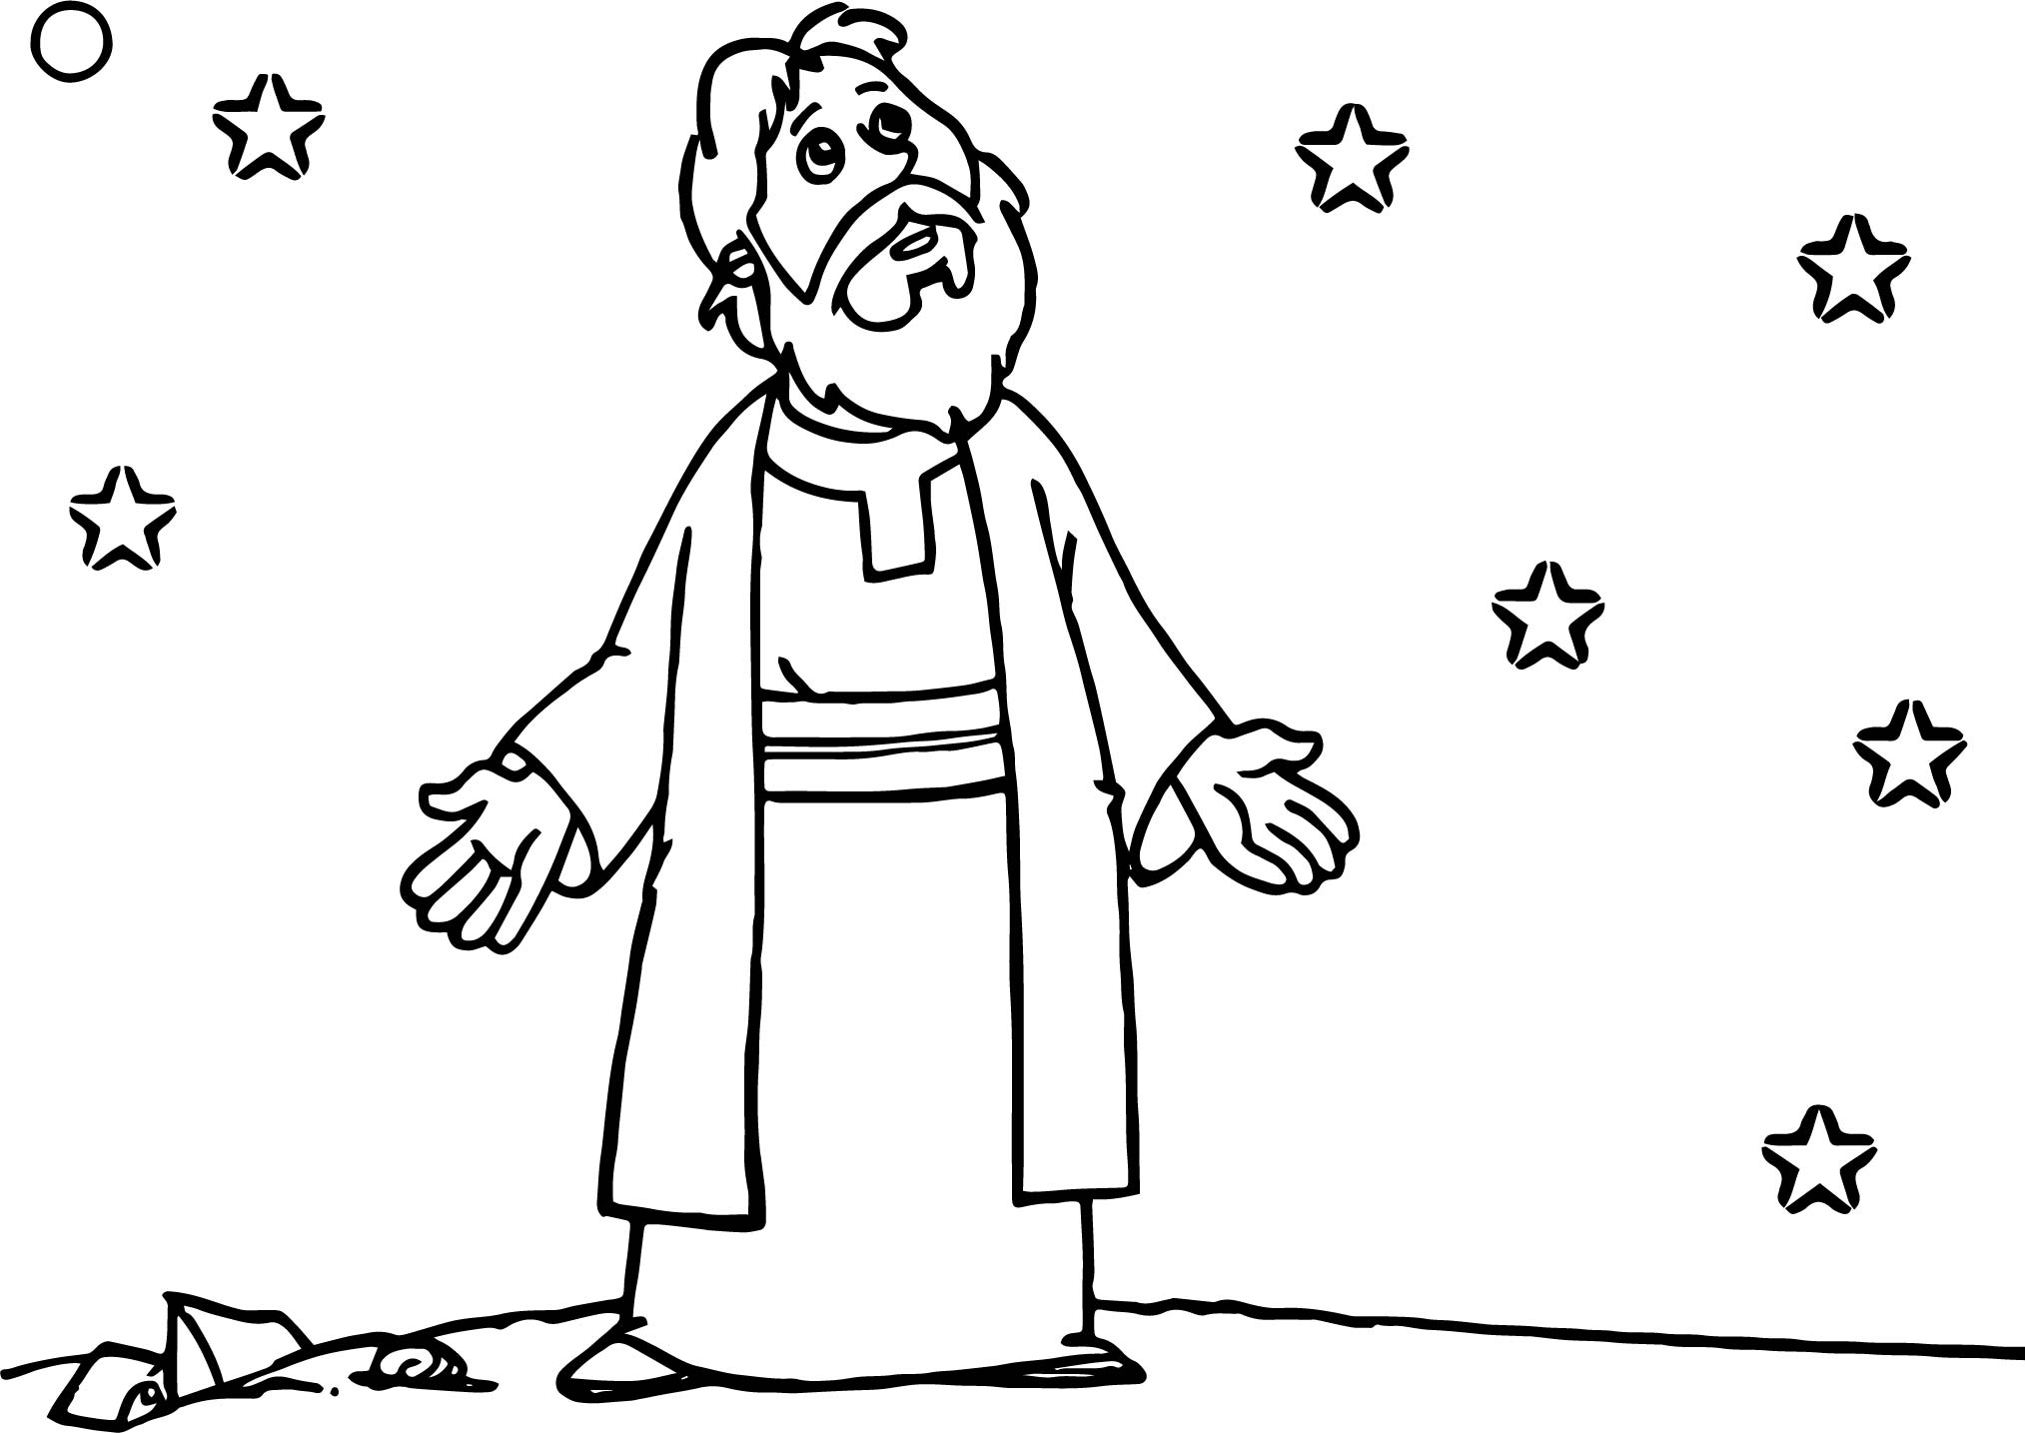

God promised Abraham children and grandchildren, as many as the stars

Additional ideas for you to try at home
Read the story of Abraham and Isaac in Genesis 18 verses 17-19 and Genesis 22 verse 1-19

Make a salt dough or card mobile Make a ram or sheep Make your own family tree

