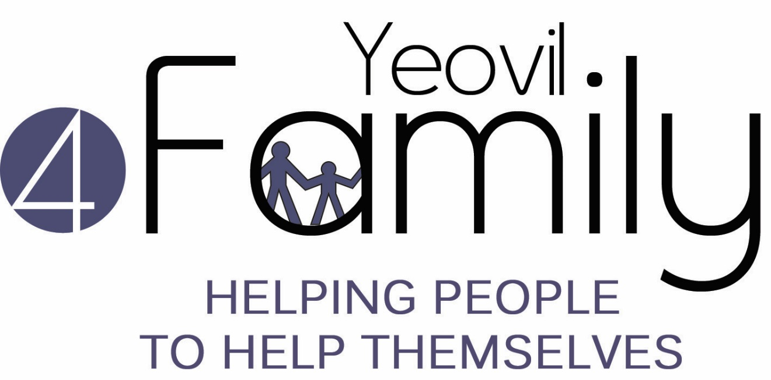 |  |  | Yeovil4Family  Referral Record for Individuals  PRIVATE AND CONFIDENTIAL
1. | Referring Agency/Organisation
 | Name
 | Organisation & Address
 | Position
 | Email
 | Telephone
 | Mobile
 | Date
2. | Individual’s Details
 | Name
 | Date of Birth
 | Address
 | Telephone
 | Reason for referral (please also see tick boxes below)
 | History/background information
Other agencies already working with the individual
Please give name of staff/worker plus contact details as known.

 | Housing Association |  | □ Yarlington  □ Other. Please specify: ………………..………..
3. | Individual’s Support Needs (please tick all the boxes where you think they need support)
 | Housing | Keeping room/home safe, clean and tidy |  |  | Past or present problems with neighbours
 |  | Notices or evictions |  |  | Arranging repairs
 |  | Rent arrears |  |  | Other (state)
 | Finance | Paying rent |  |  | Claiming benefits
 |  | Paying bills |  |  | Clearing debts
 |  | Budget planning |  |  | Other (state)
 | Support networks/family/friends | Family links |  |  | Friends
 |  | Other social networks |  |  | Isolation
 |  | Domestic abuse |  |  | Offending
 |  | Behaviour management |  |  | Other (state)
 | Meaningful use of time | Training |  |  | Education
 |  | Employment |  |  | Interests
 |  | Literacy needs |  |  | Help with language
 |  | Accessing child care |  |  | Other (state)
 | Diversity | Cultural needs |  |  | Religious needs
 |  | Personal preferences |  |  | Other (state)
 | Health and well being | Getting a doctor |  |  | Getting a dentist
 |  | Exercise |  |  | Hygiene
 |  | Diet |  |  | Getting support from other agencies
 |  | Physical health |  |  | Mental health
 |  | Addictions |  |  | Other (state)
 | Are you pregnant? (For women applicants only) | Yes No  If yes, baby’s due date:
4. | Impact of Referral
 | If you hadn’t referred the Individual to the Programme, what would you have done to support them? Eg. Supported them direct, signposted to another service etc.
 | By referring the individual to the Programme, do you believe that it will have saved staff time within your organisation? Please give an estimate if you are able.
5. | Individual’s Engagement
 | Does the individual positively engage with services? YES/NO (please delete as appropriate)
If so, are they willing to engage with the support from Yeovil4Family? The individual needs to agree to support.
YES/NO (please delete as appropriate)

(Please note that if the answer is ‘no’ to either of the above questions, the referral is unlikely to be accepted.)
 | Are you as the referrer happy to facilitate a warm introduction to the individual? YES/NO (see supporting information sheet for more details on warm introductions)
6. | Risk Assessment
 | In your professional opinion are there any issues / concerns we should know about concerning the household which may impact on the health & safety of our lone working staff and volunteers? Eg specific household members, pets, visitors to the household, known Police concern etc. (Please note that if this is left blank we will not be able to work with the individual.)
7. | Data Protection
Has the individual consented to this referral? YES/NO (please delete as appropriate)

We are committed to protecting any personal information we hold about individuals. We will follow the principles outlined in the General Date Protection Regulations 2018 for processing that information in accordance with our Data Protection Policy. For more information please see our privacy policy on our website: http://yeovil.cc/privacy
Please return this completed form to: Referrals
By post: In a sealed envelope with “Private and Confidential: To be opened by recipient only”
Referrals
Yeovil4Family
The GateWay
Addlewell Lane
Yeovil
Somerset
BA20 1QN
By SECURE Email: deanne.mahony@yeovil4family.org.uk

