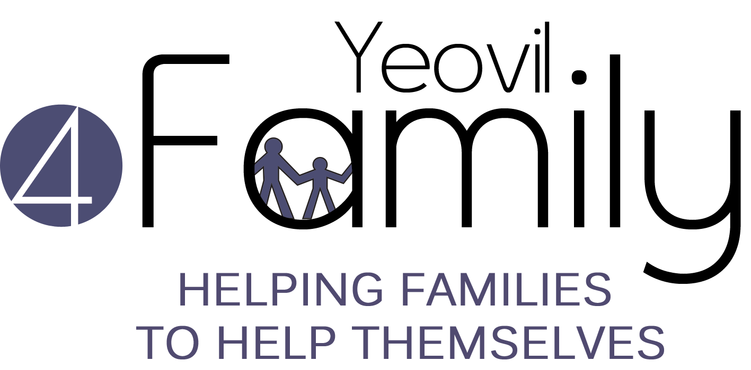 |  | Yeovil4Family  Referral Record for Families  PRIVATE and CONFIDENTIAL
1. | Referring Agency/Organisation
 | Name
 | Organisation & Address
 | Position
 | Email
 | Telephone
 | Mobile
 | Date
2. | Family
 | Name/s of all family members with all Dates of Birth
 | Address
 | Telephone
 | Reason for referral
 | History/background information
Other agencies already working with family
Please give name of staff/worker etc.

 | Housing Association | □ Yarlington  □ Other. Please specify: …………………………………………………..
 | If any of the children are subject to a Child Protection Plan/CIN or have a Social Worker please tell us here.
3. | Impact of Referral
 | If you hadn’t referred the family to the 4Family Programme, what would you have done to support the family? Eg. Supported them direct, signposted to another service etc.
 | By referring the family to the 4Family Programme, do you believe that it will have saved staff time within your organisation? Please give an estimate if you are able.
4. | Family Engagement
 | Do the family positively engage with services? YES/NO (please delete as appropriate)
If so, are they willing to engage with the support from Yeovil4Family? The family must agree to this support.
YES/NO (please delete as appropriate)
 | Are you as the referrer happy to facilitate a warm introduction to the family? YES/NO (see supporting information sheet for more details on warm introductions)
 | (Please note that if the answer is ‘no’ to either of the above questions, the referral is unlikely to be accepted.)
5. | Risk Assessment
 | In your professional opinion are there any issues / concerns we should know about concerning the household which may impact on the health & safety of our lone working staff and volunteers? Eg specific household members, pets, visitors to the household, known Police concern etc. (Please note that if this is left blank we will not be able to work with the family.)
6. | Data Protection
Has the family consented to this referral? YES/NO (please delete as appropriate)

We are committed to protecting any personal information we hold about individuals. We will follow the principles outlined in the General Date Protection Regulations 2018 for processing that information in accordance with our Data Protection Policy. For more information please see our privacy policy on our website: http://yeovil.cc/privacy
Please return this completed form to: Referrals
By post: In a sealed envelope with “Private and Confidential: To be opened by recipient only”
Referrals
Yeovil4Family
The GateWay
Addlewell Lane
Yeovil
Somerset
BA20 1QN
By SECURE Email: deanne.mahony@yeovil4family.org.uk

